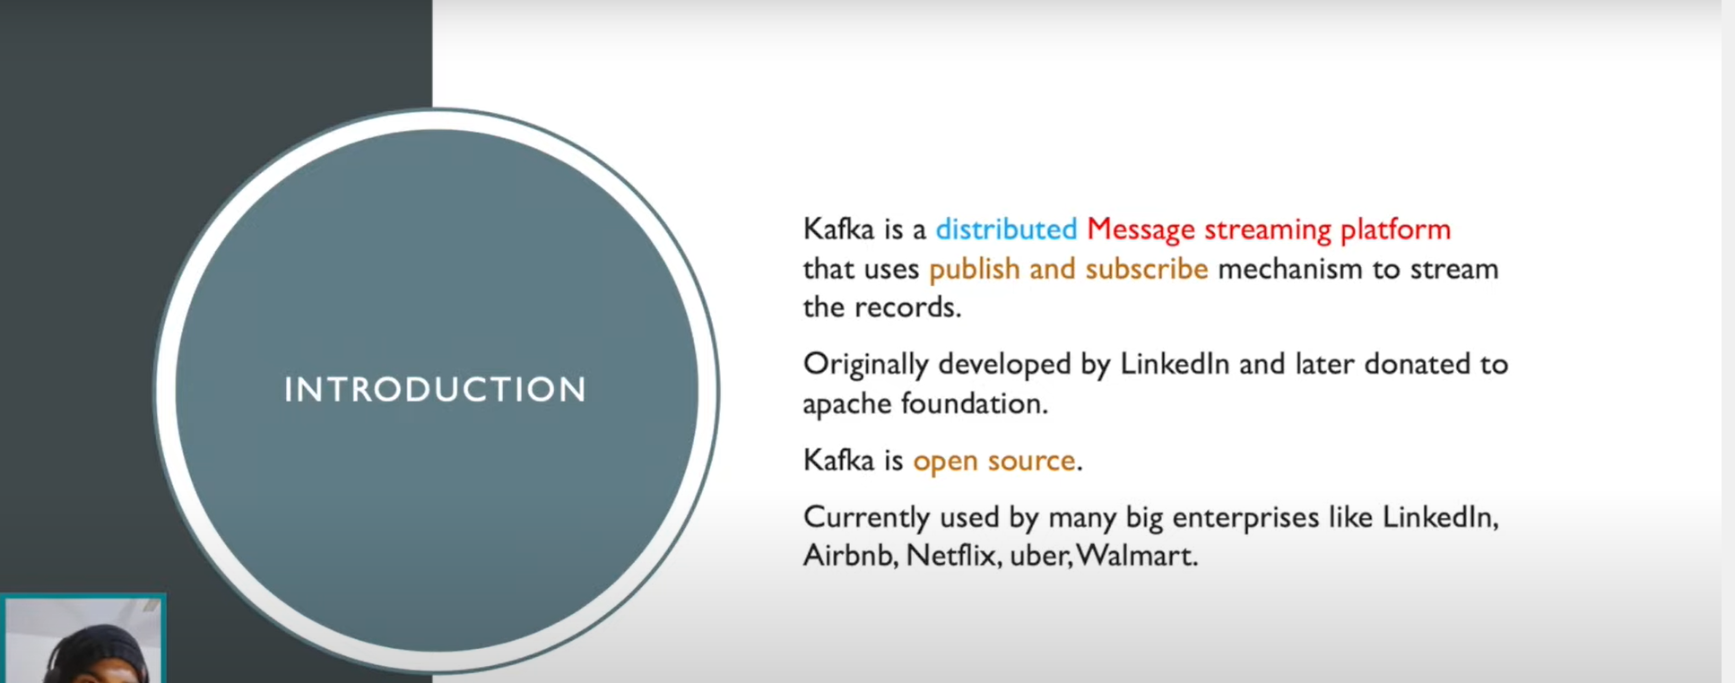

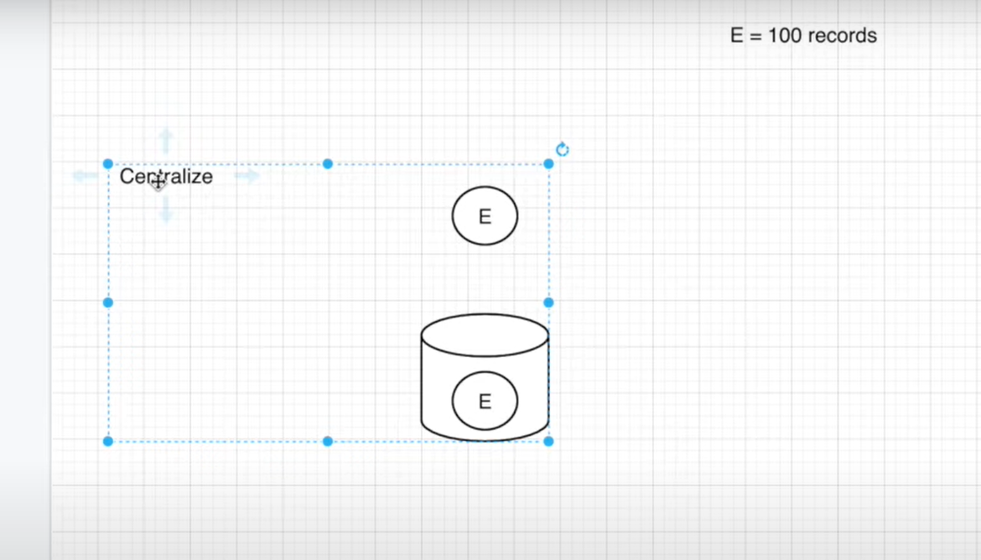

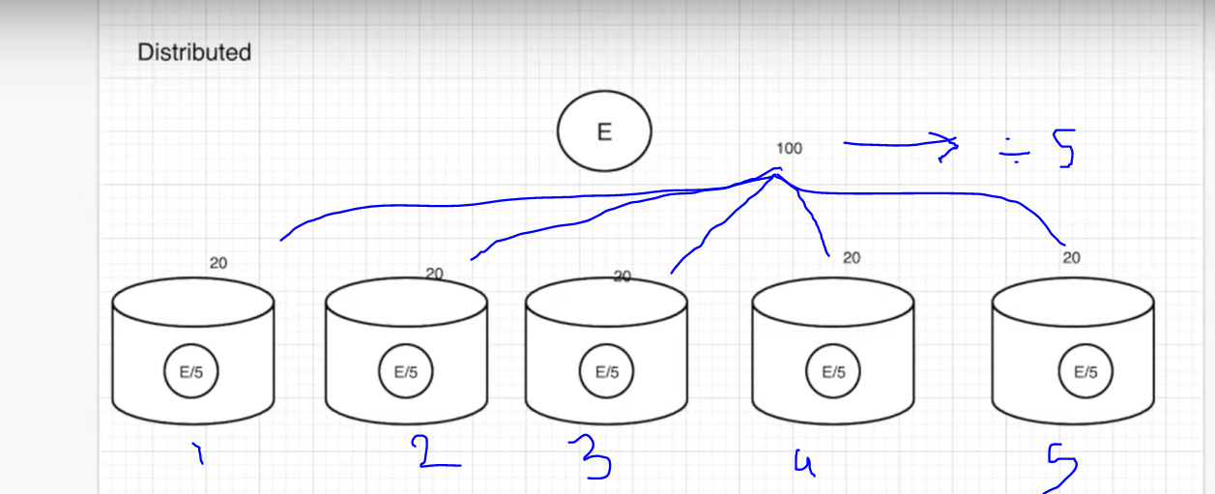

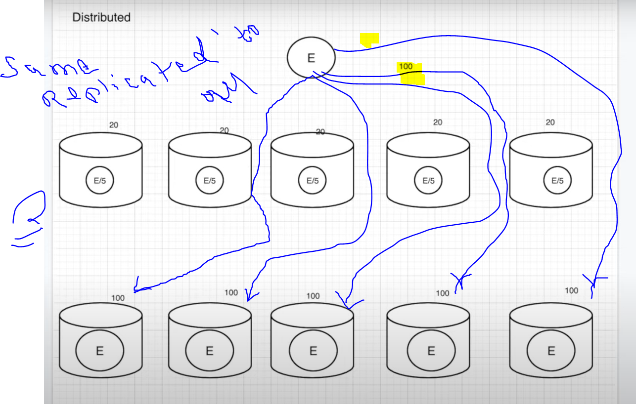

Without Kafka :- No of connections

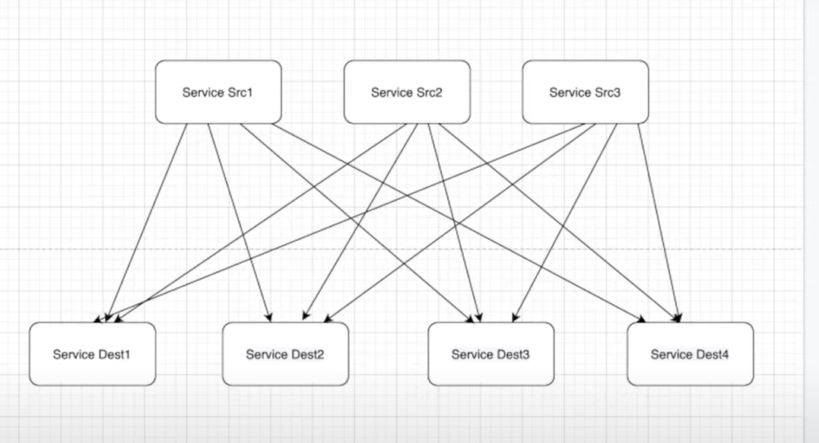

With kafka :- No Of connection = no of pub + no of sub

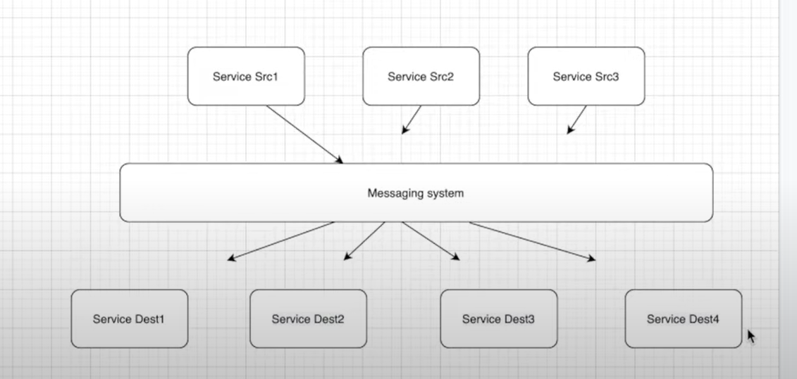

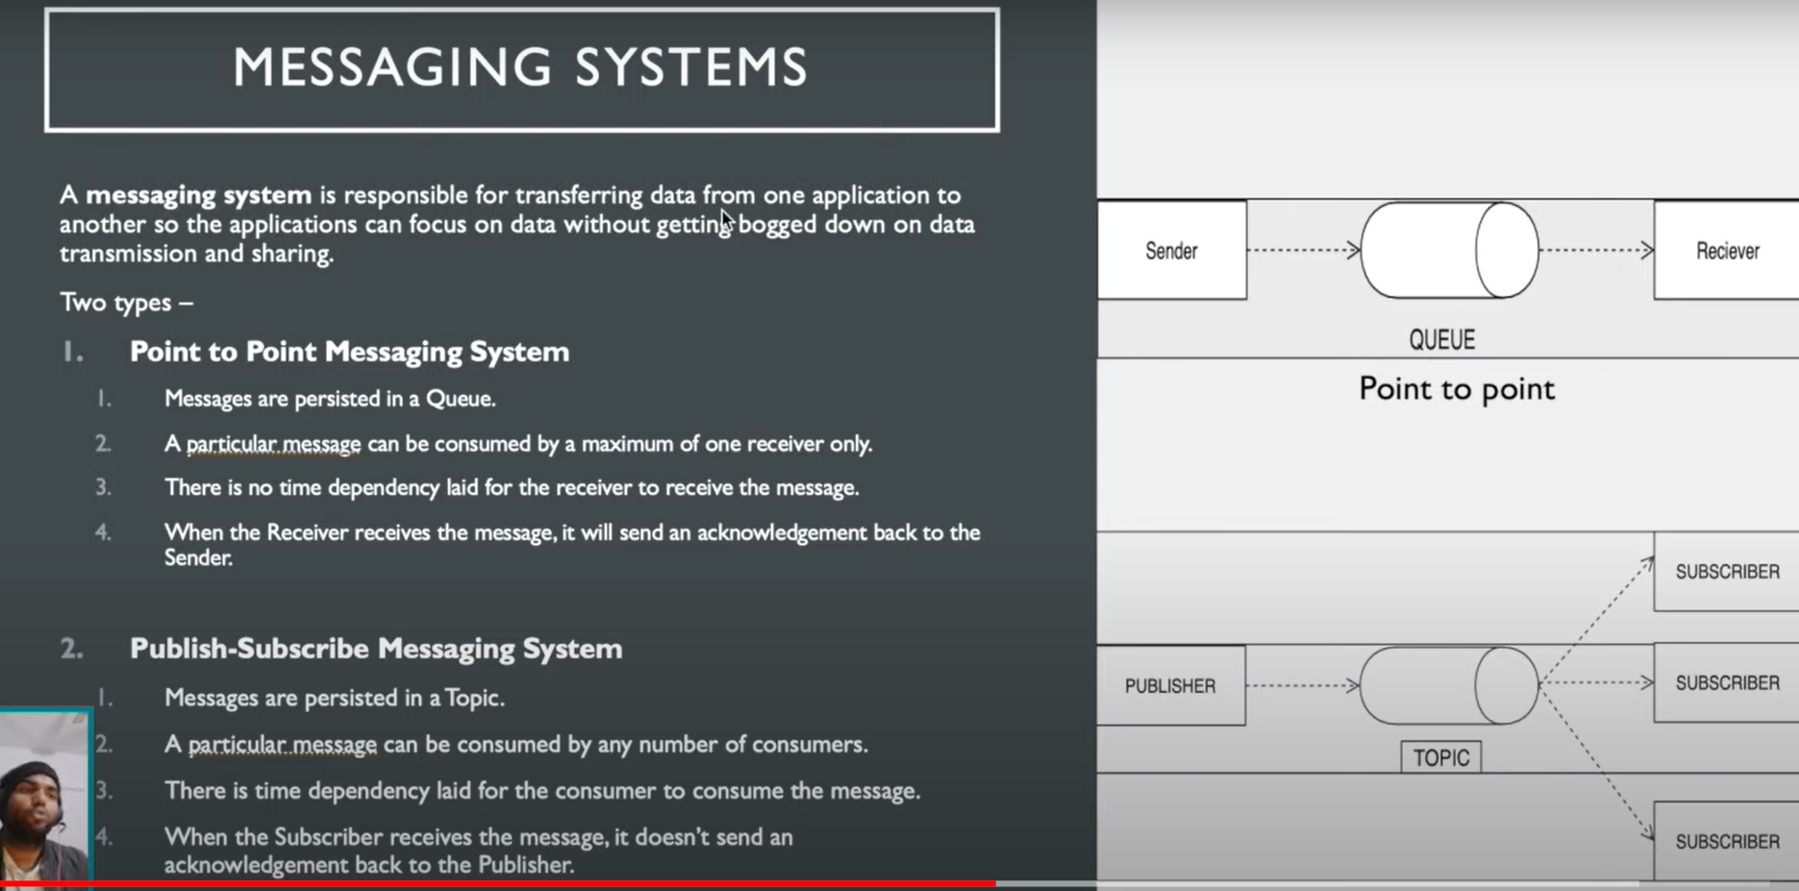

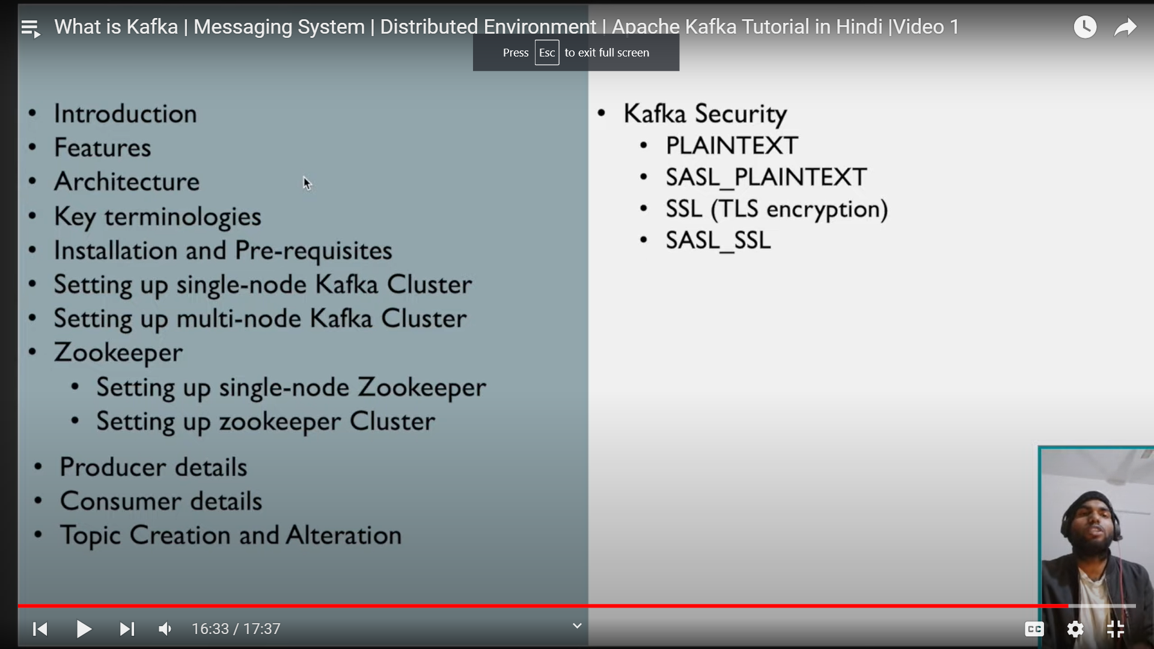

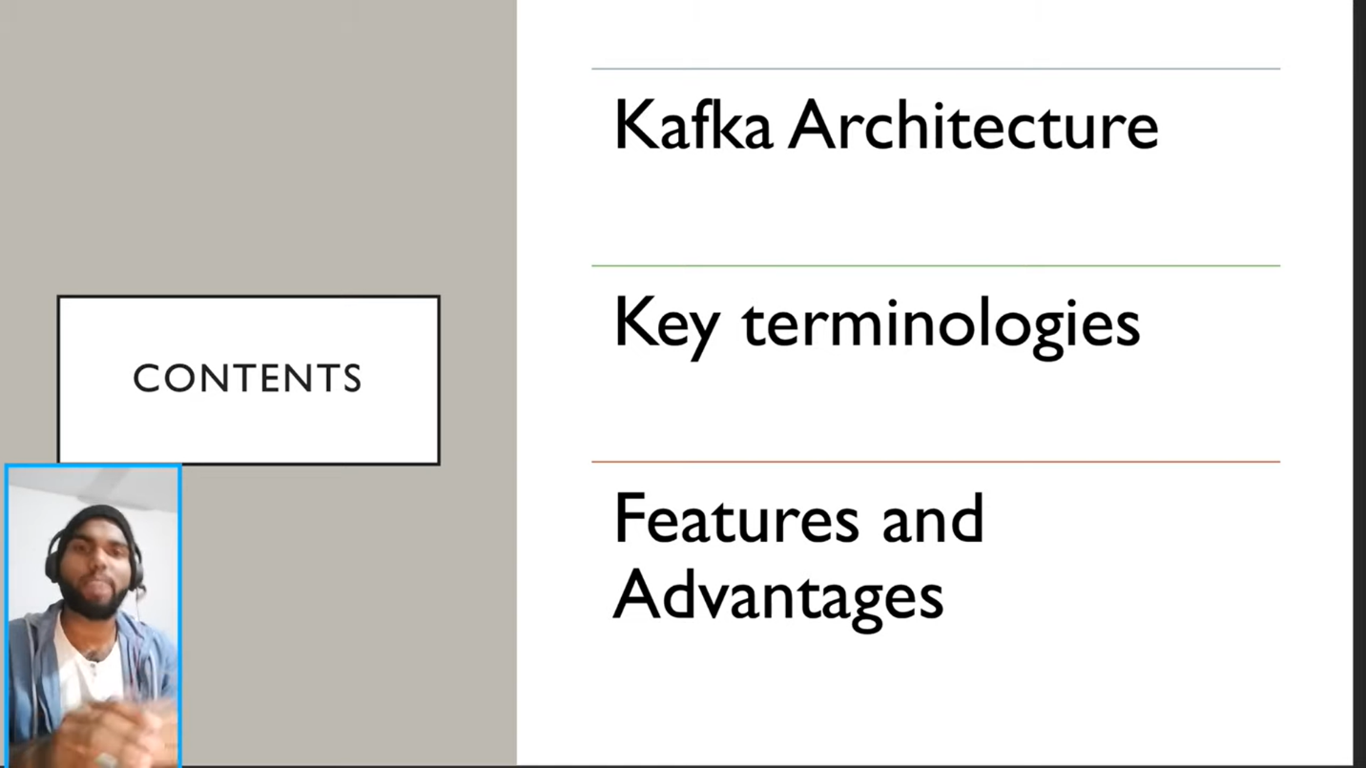

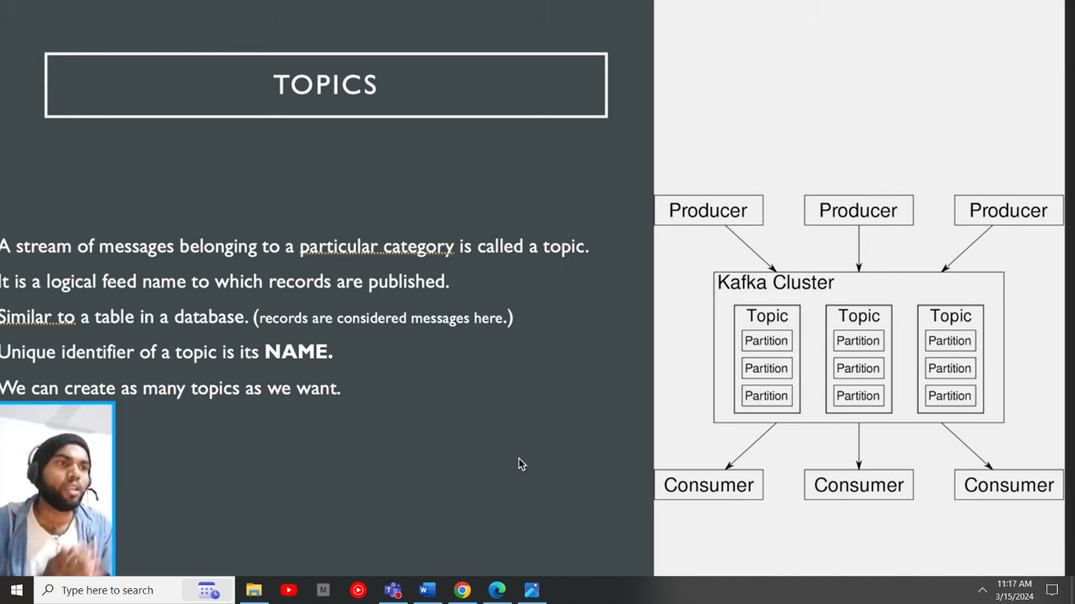

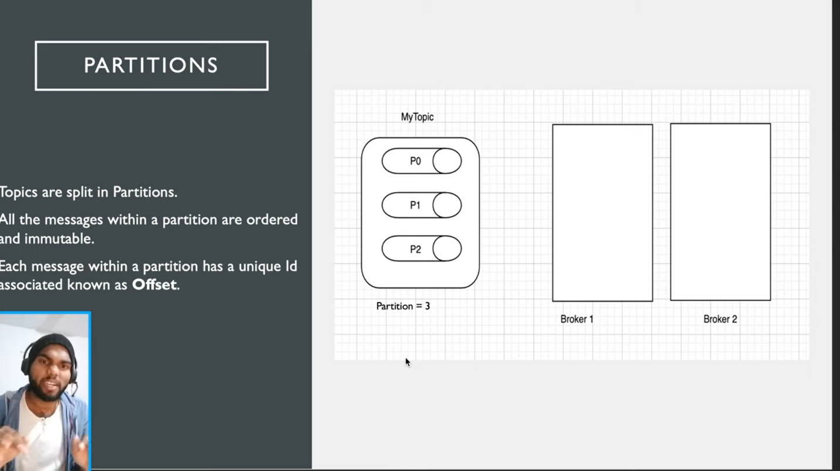

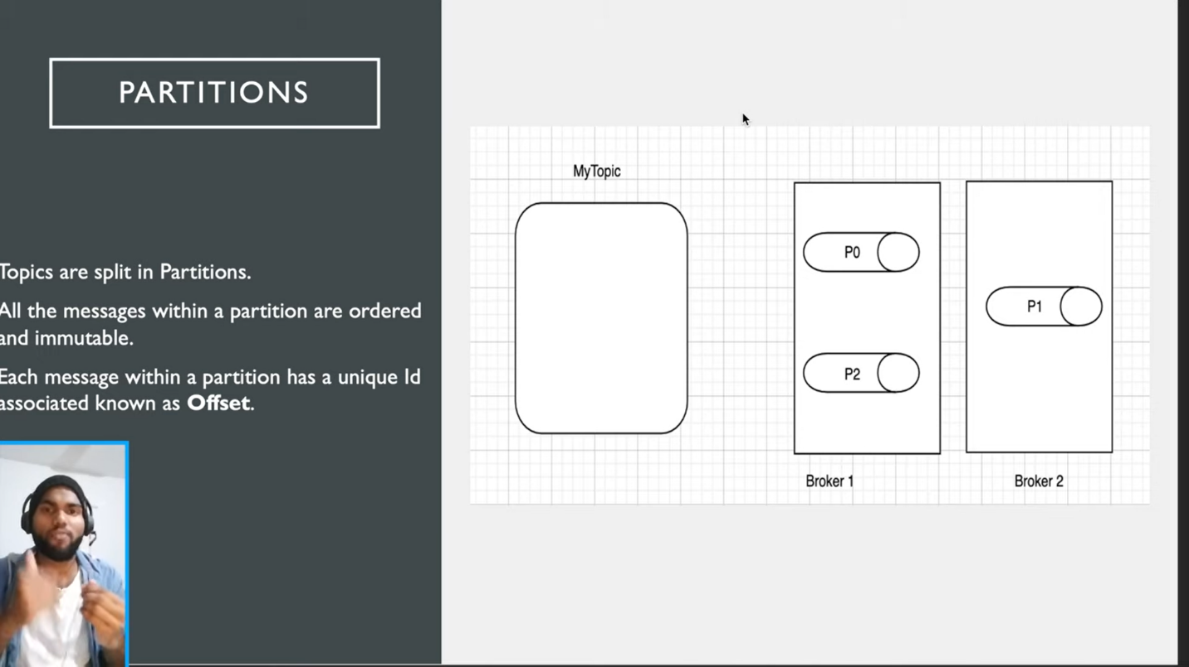

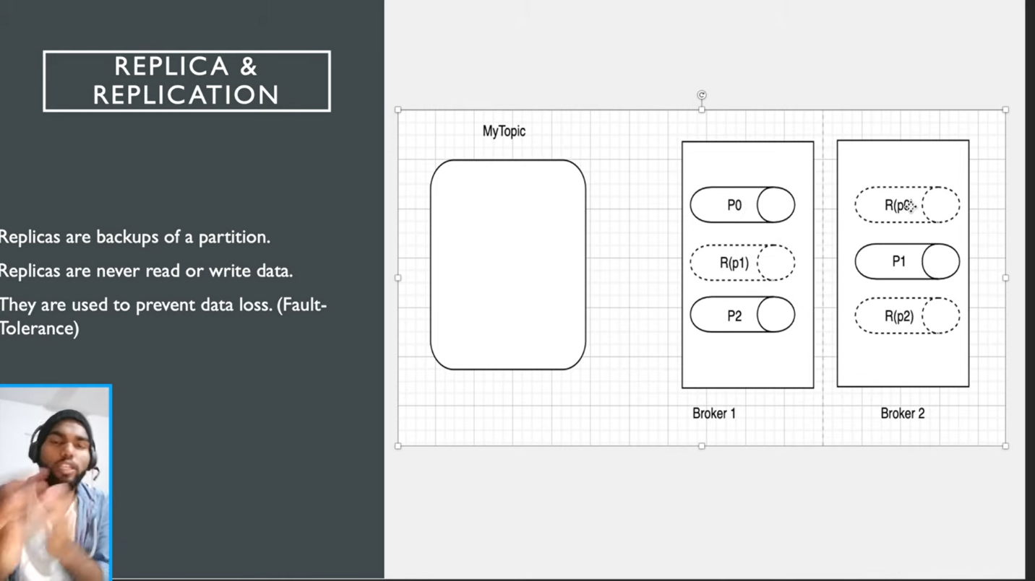



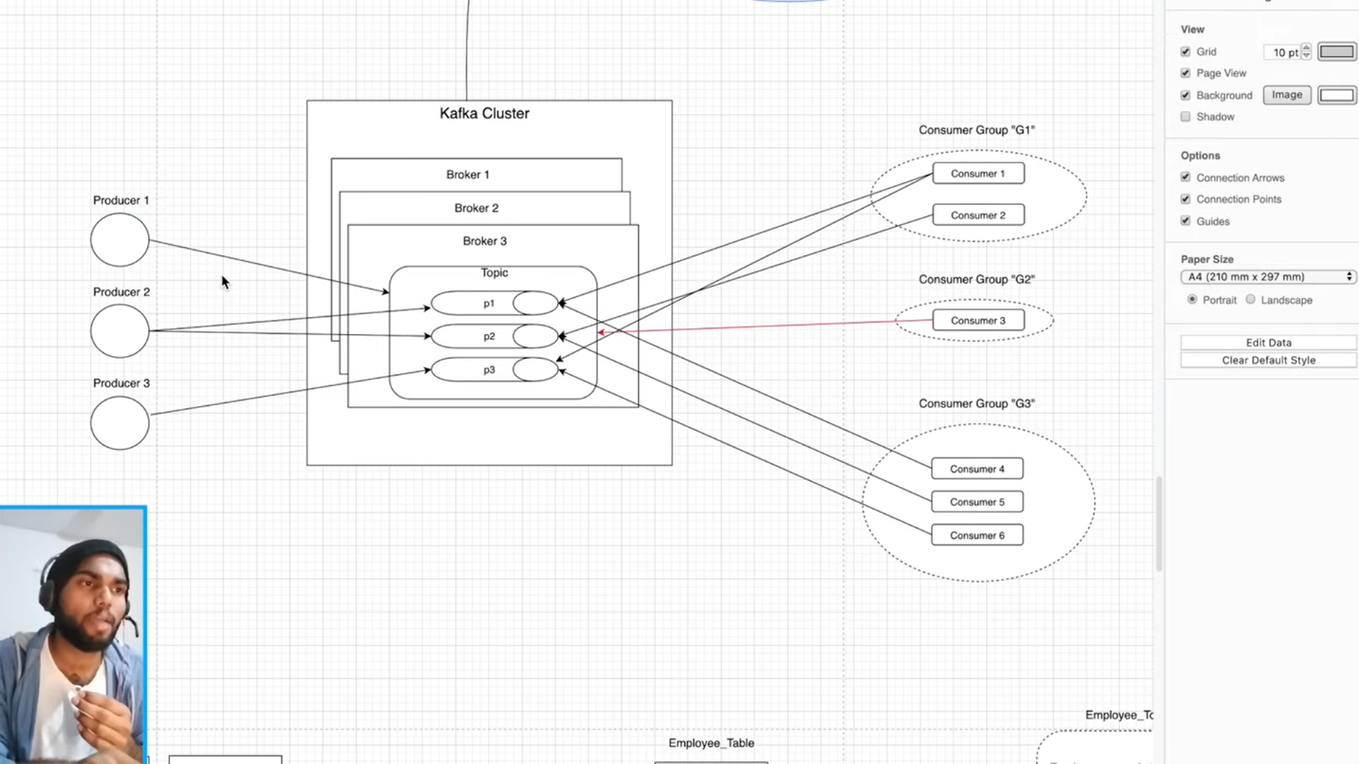

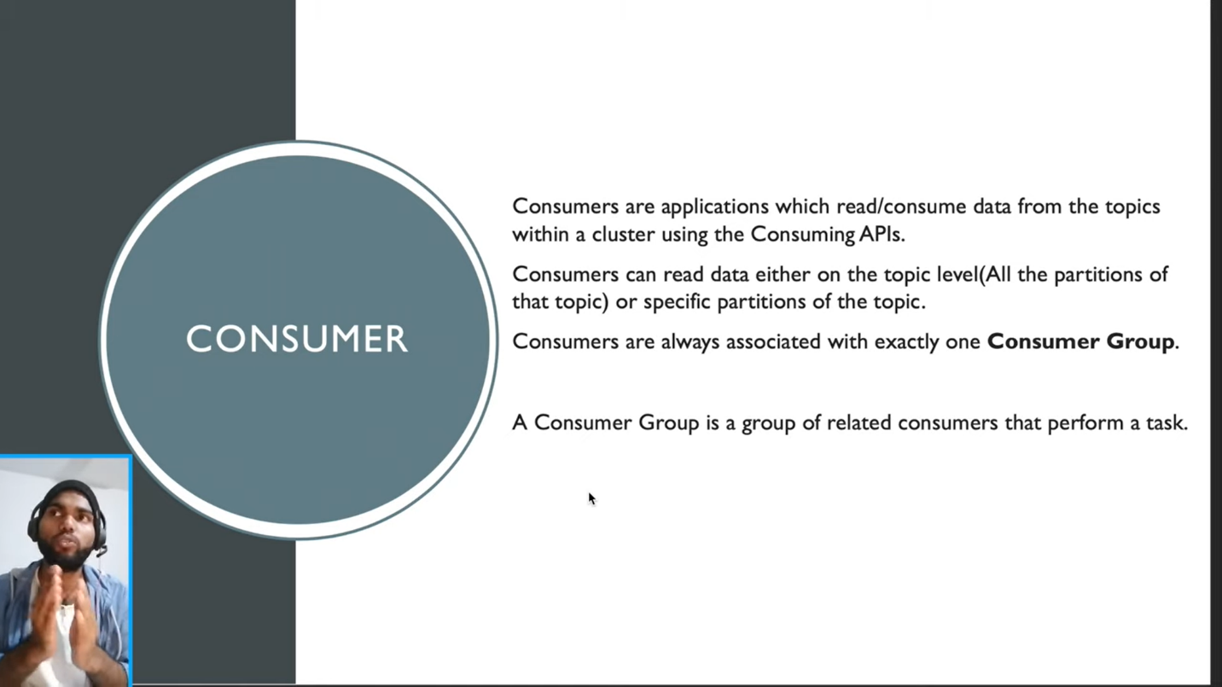

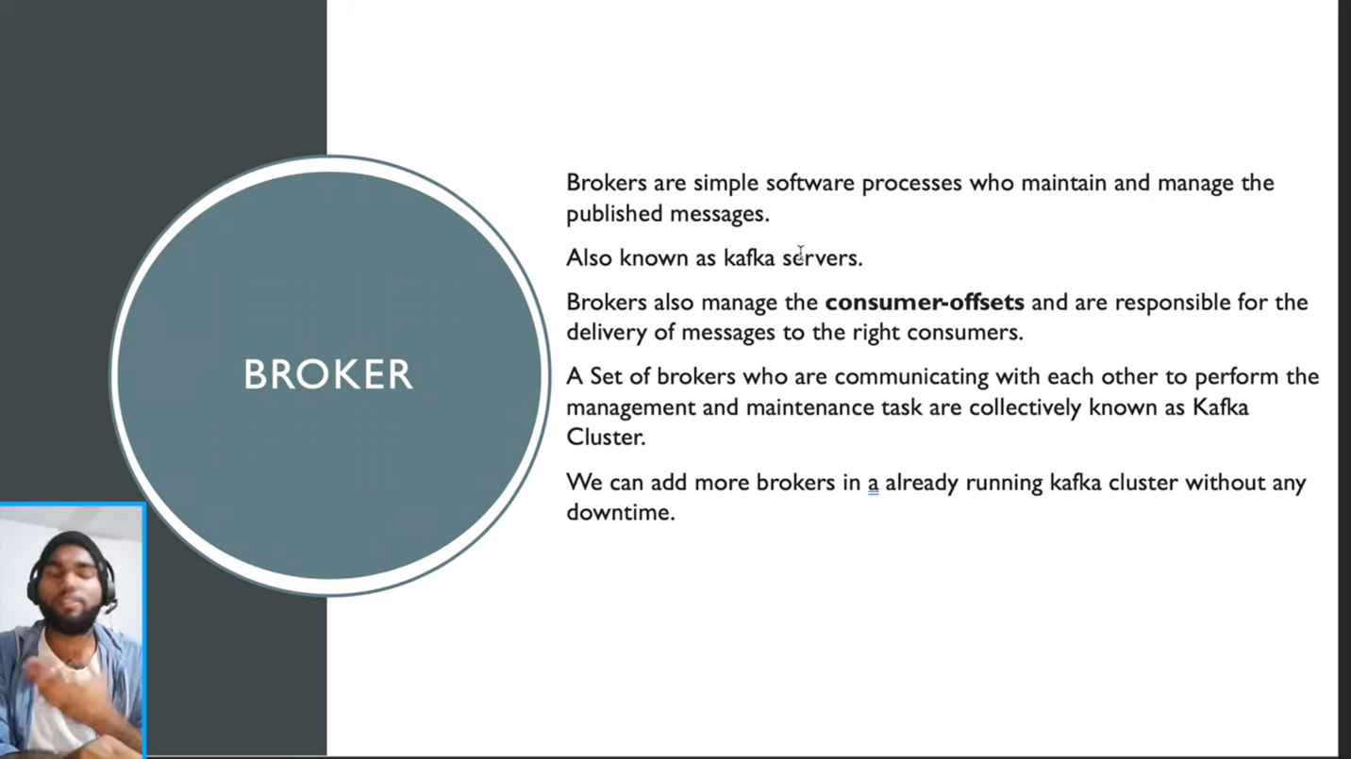

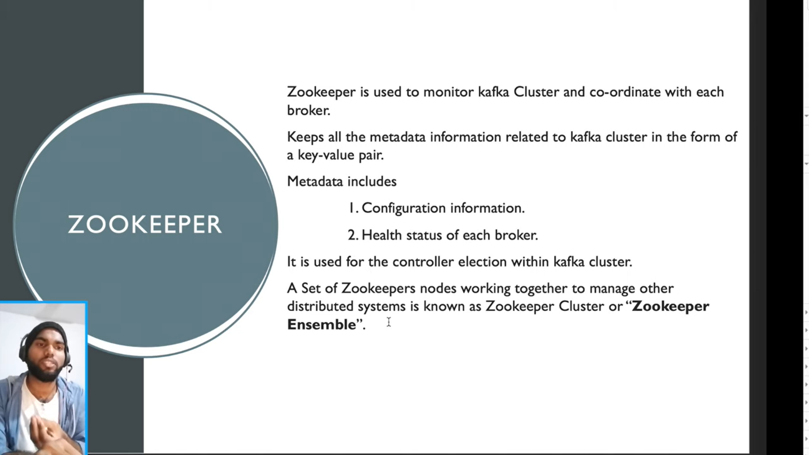

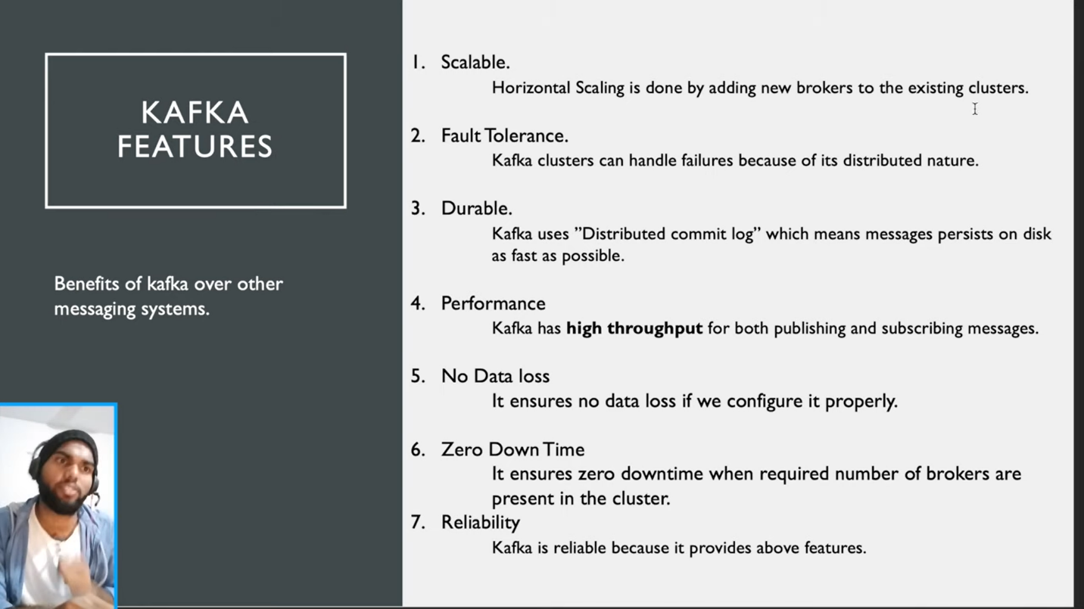

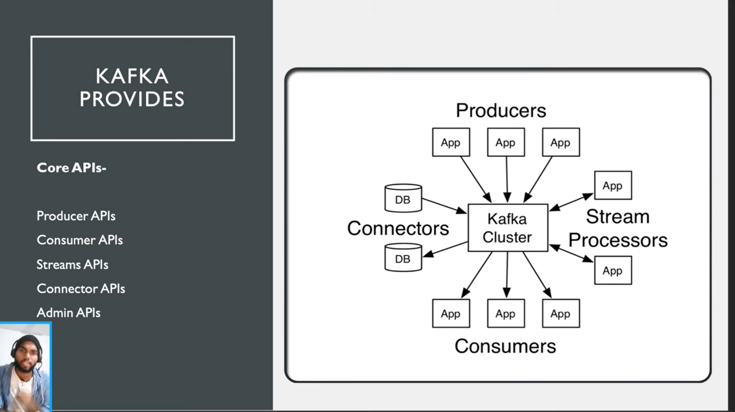



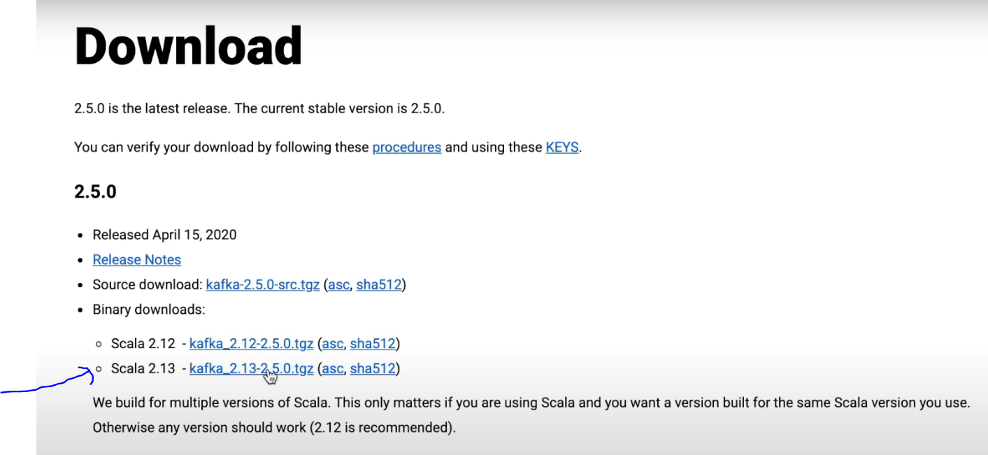

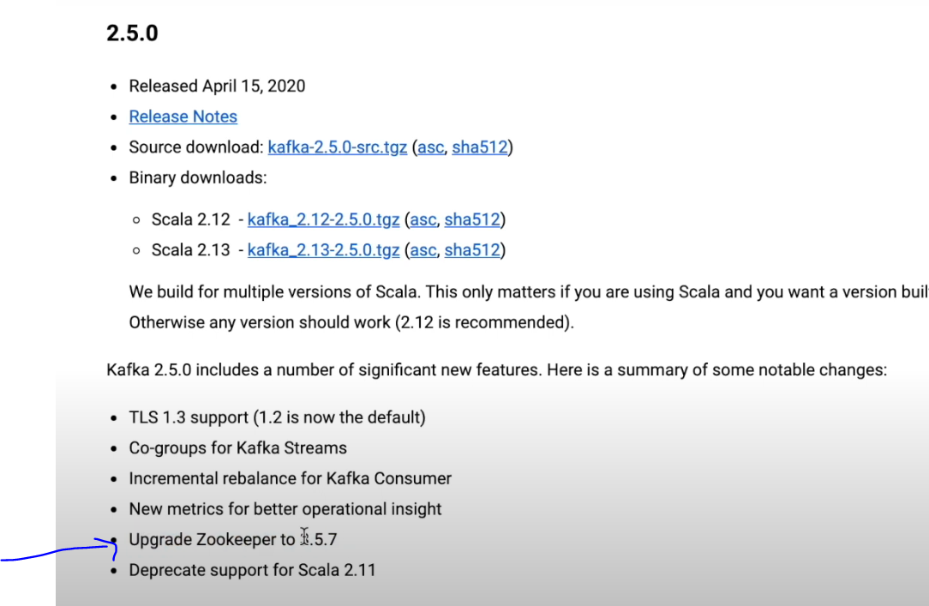

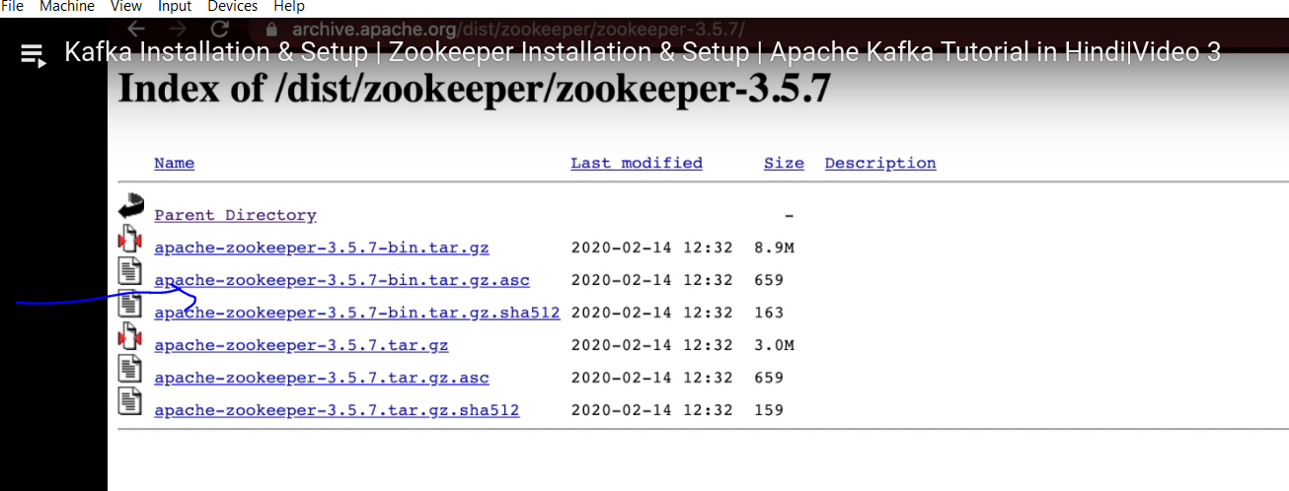

From command line

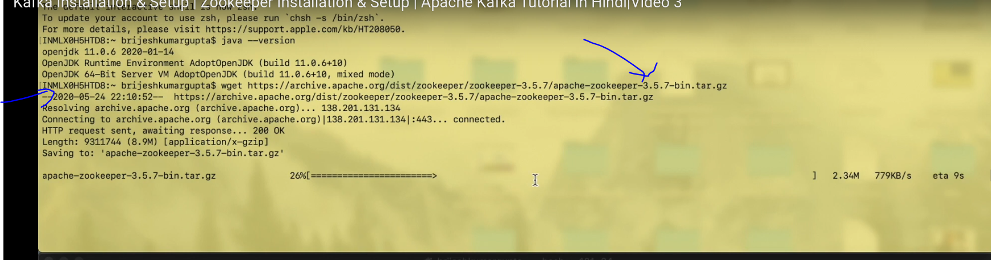

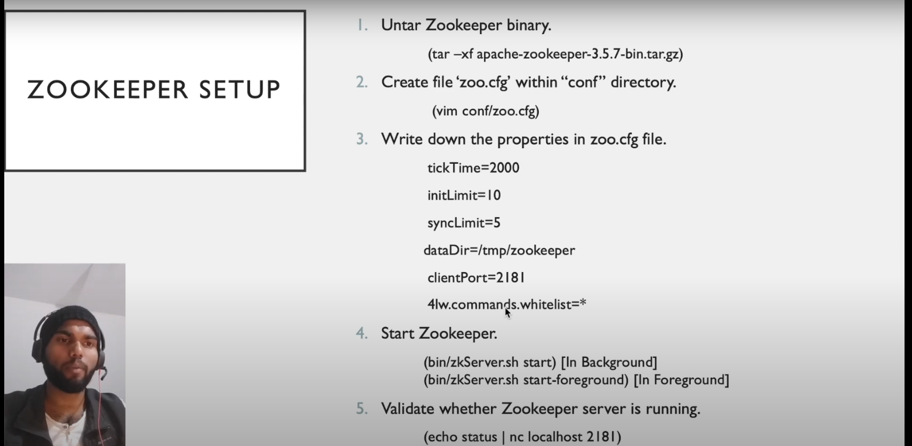

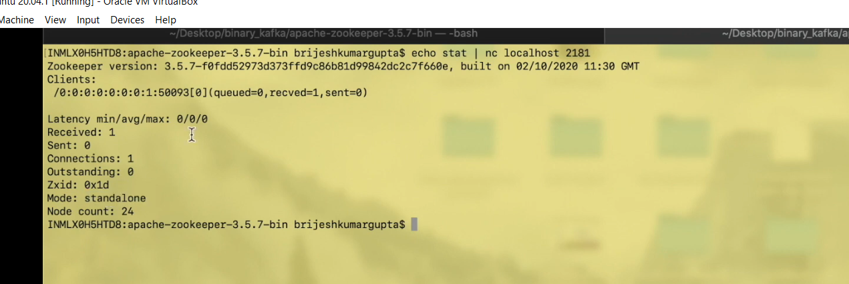

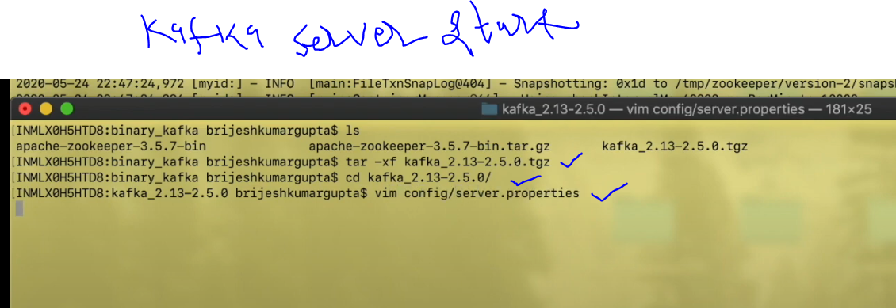

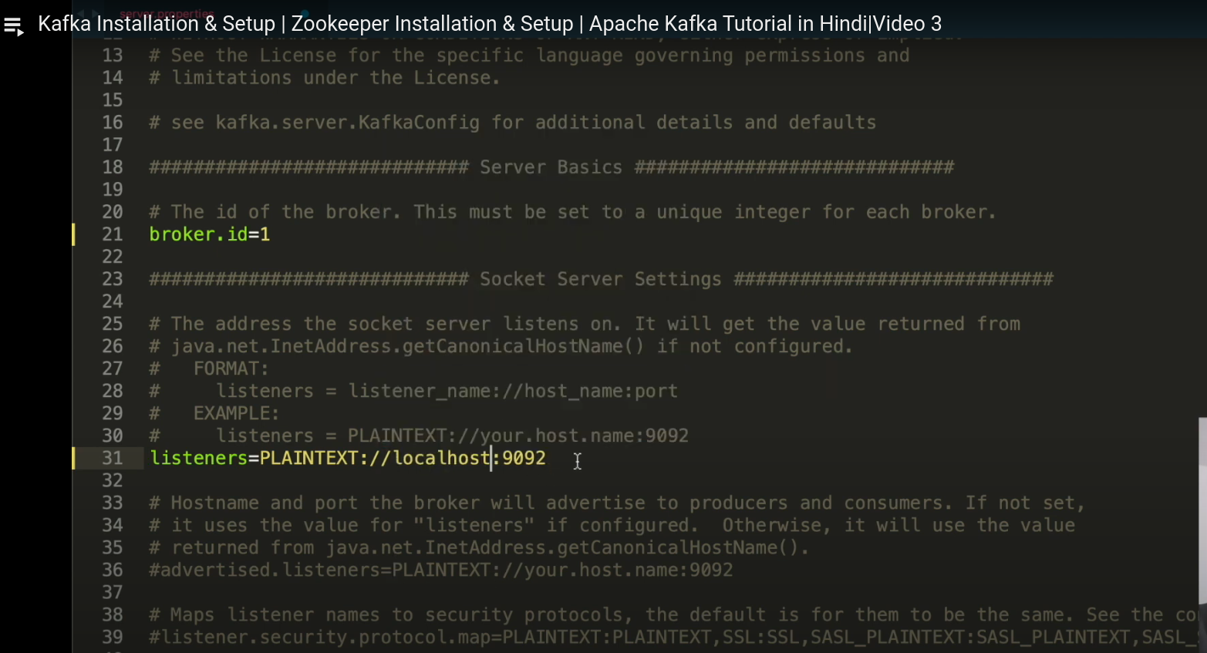

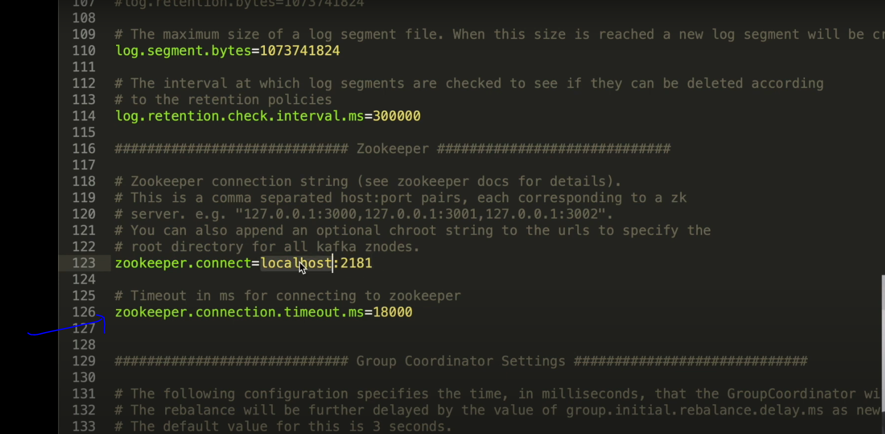

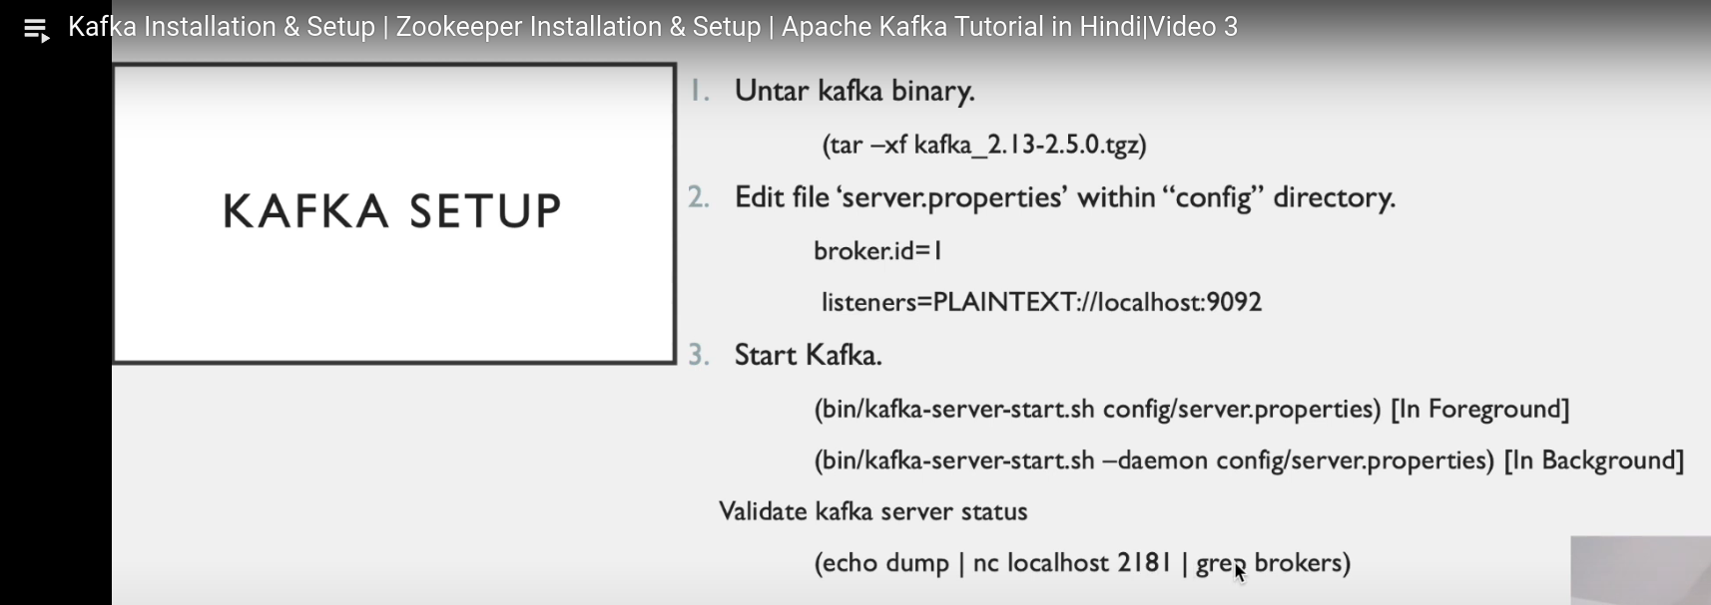

nc -zvw 1 158.155.121.106 1-100

echo "" | nc -vn 158.155.121.106 80

history

ifconfig

cd kafka

cd kafka_2.13-3.6.1/

vi config/server.properties

bin/kafka-server-start.sh config/server.properties

cd bin

./kafka-server-start.sh config/server.properties

./bin/kafka-server-start.sh config/server.properties

history

java --version

2005 ls -l

2006 tar -xzvf kafka_2.13-3.6.1.tgz

2007 ll

2008 cd apache-zookeeper-3.8.3-bin/

2009 ll

2010 cd conf/

2011 ll

2012 cp zoo_sample.cfg zoo.cfg

2013 ll

2014 vi zoo.cfg

2015 cd ..

2016 ls

2017 cd bin

2018 ls

2019 ls -l

2020 zkServer.sh

2021 ./zkServer.sh

2022 ./zkServer.sh start-forground

2023 ./zkServer.sh start-foreground

2024 ./zkServer.sh start

2025 clear

2026 echo stat

2027 echo stat | nc localhost 2181

2028 ./zkServer.sh stop

2029 ./zkServer.sh start-foreground

2030 history

echo dump | nc localhost 2181 | grep broker

./bin/kafka-server-stop.sh

cd logs

tail -100f server.log

------------------

The echo dump command is specifically designed to interact with ZooKeeper and retrieve a detailed status of all the ephemeral nodes, including broker information. ZooKeeper has a set of predefined commands, often referred to as “four-letter words,” that serve specific purposes. Some of these commands include:

* stat: Provides server statistics.
* ruok: Checks if the server is running and responds with “imok”.
* mntr: Outputs various server metrics.
* conf: Displays the server configuration.

When you send echo dump, ZooKeeper understands it as a request to dump the current state of all sessions and ephemeral nodes.

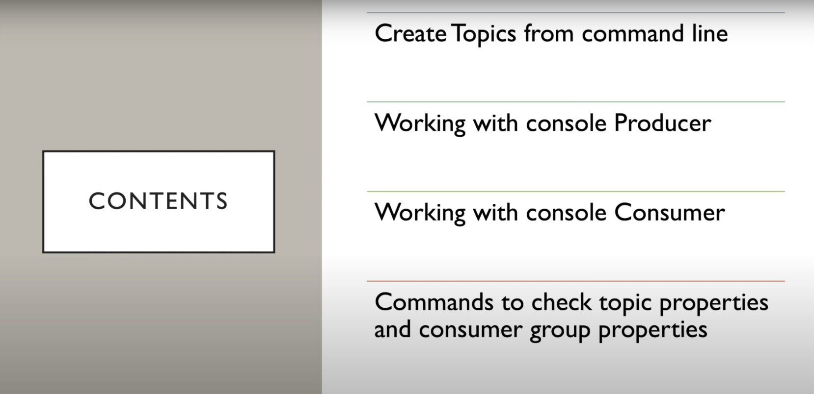

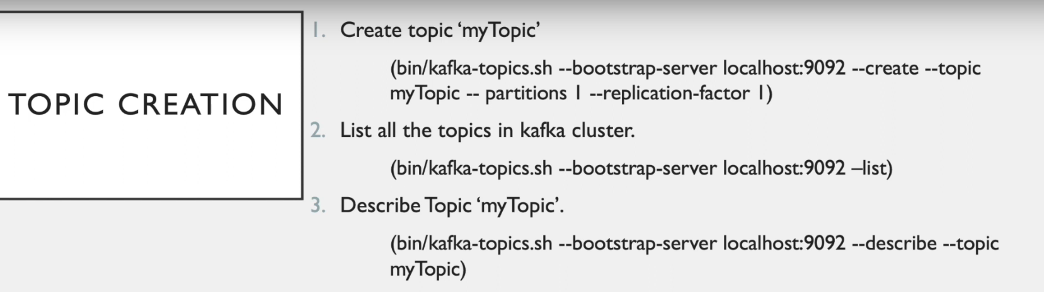



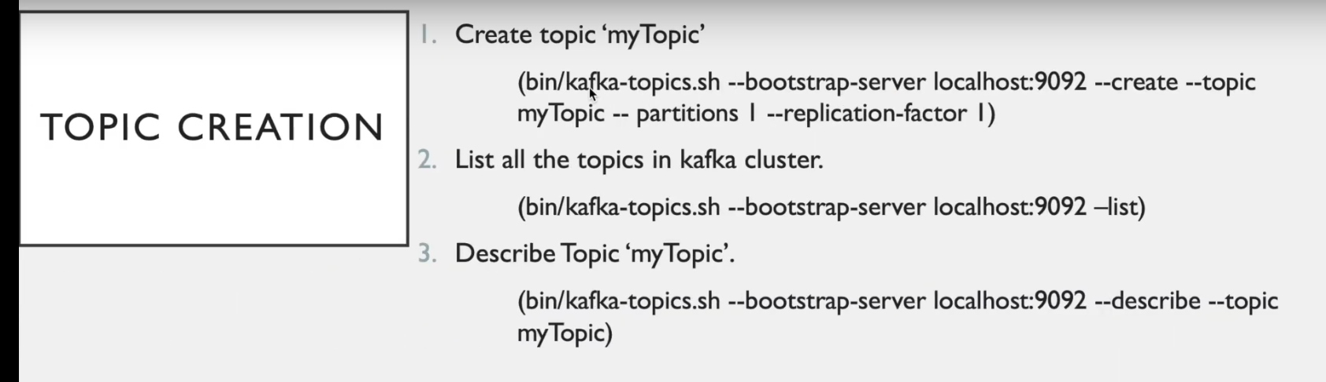

/kafka-topics.sh --bootstrap-server localhost:9092 --create --topic myTopic --partitions 1 --replication-factor 1

Created topic myTopic.

./kafka-topics.sh --bootstrap-server localhost:9092 –list

./kafka-topics.sh --bootstrap-server localhost:9092 --describe --topic myTopic

: Topic: myTopic TopicId: fdHB6oXBTuuDtoYHmBcmfQ PartitionCount: 1 ReplicationFactor: 1 Configs:

Topic: myTopic Partition: 0 Leader: 1 Replicas: 1 Isr: 1

Start Producer :

./kafka-console-producer.sh --bootstrap-server localhost:9092 --topic myTopic

Write some messages

Start Consumer :

./kafka-console-consumer.sh --bootstrap-server localhost:9092 --topic myTopic --from-beginning

Every consumer is associated with consumer group ,

To see that ,

./kafka-consumer-groups.sh --bootstrap-server localhost:9092 –list

o/p : console-consumer-90678

now ,describe this group

/kafka-consumer-groups.sh --bootstrap-server localhost:9092 --describe --group console-consumer-90678

Consumer Offset Topic Cretaed by kafka to Store info about :information about consumer written here

./kafka-topics.sh --bootstrap-server localhost:9092 –list

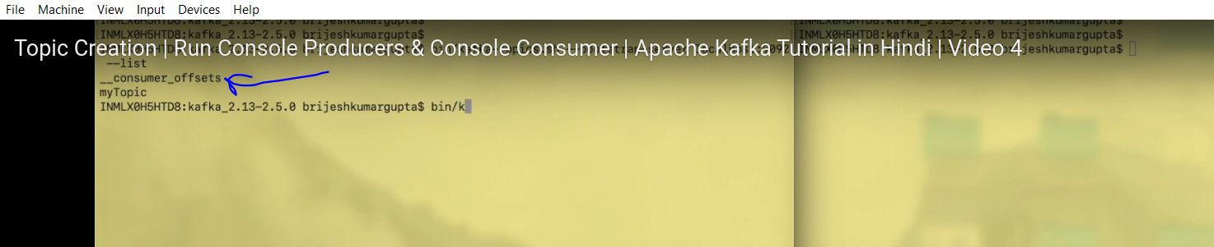

Multiple Consumer and Multiple Producer :

Run Producer command in different windows on same topic

And publish messages

./kafka-console-producer.sh --bootstrap-server localhost:9092 --topic myTopic

./kafka-console-producer.sh --bootstrap-server localhost:9092 --topic myTopic

./kafka-console-consumer.sh --bootstrap-server localhost:9092 --topic myTopic --from-beginning

./kafka-console-consumer.sh --bootstrap-server localhost:9092 --topic myTopic --from-beginning

For each consumer created , a consumer group will be created by kafka,

So in-order to created own consumer group to which consumer should belong ,

Run : ./kafka-console-consumer.sh --bootstrap-server localhost:9092 --topic myTopic --from-beginning –group myConsumerGroup

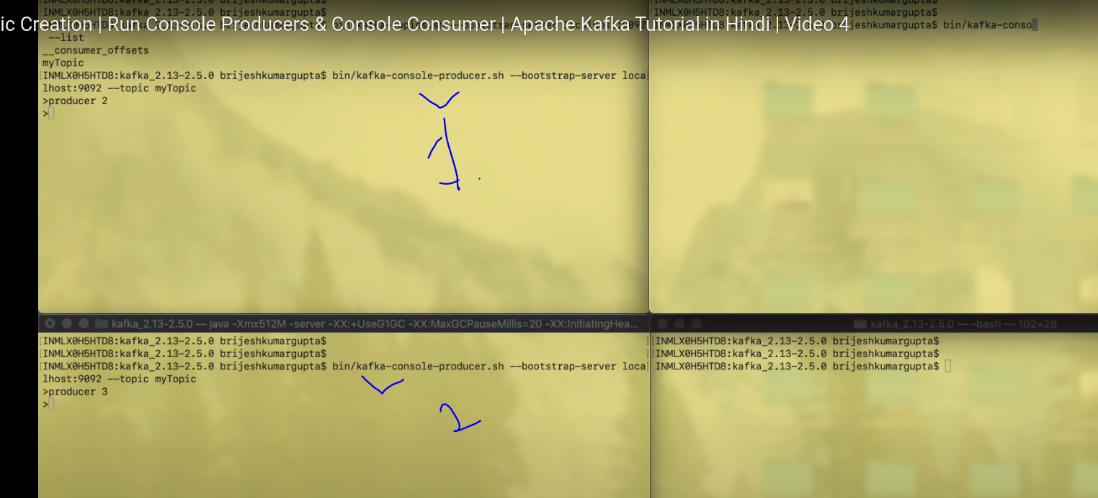

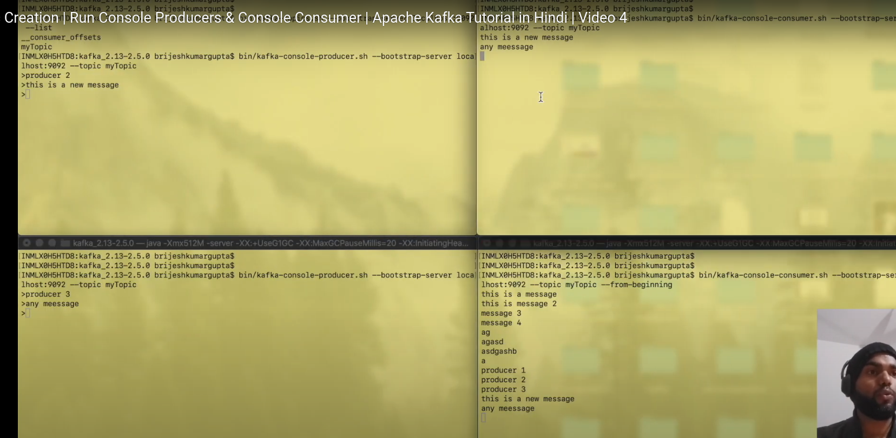

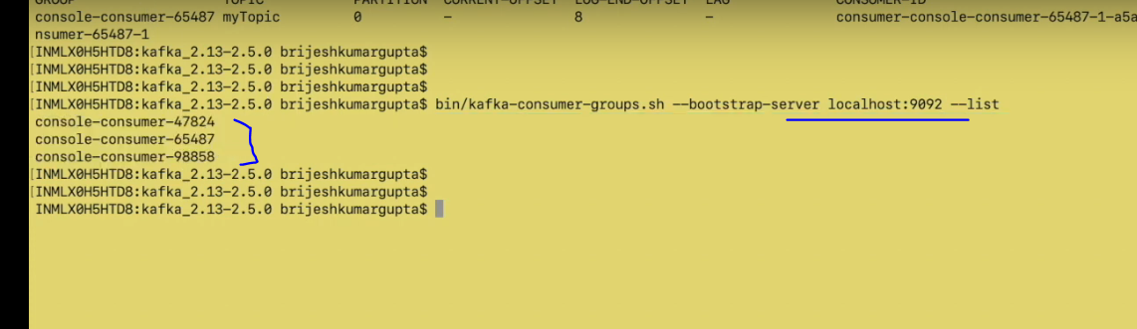

Own consumer group:

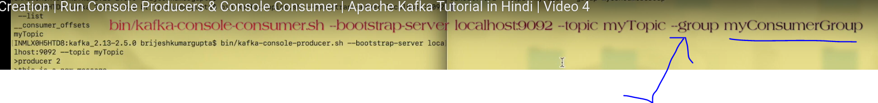



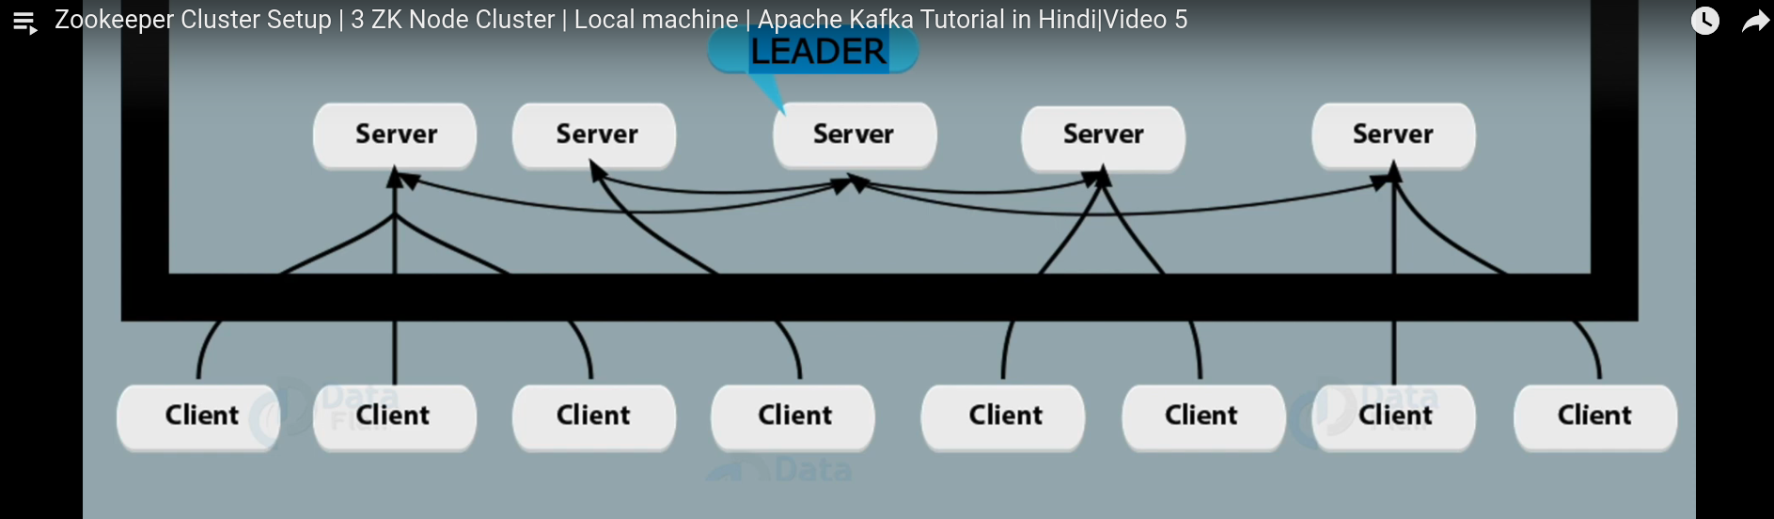

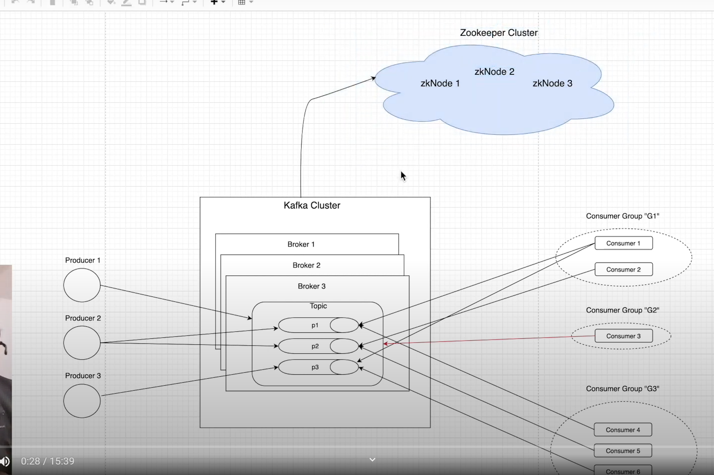



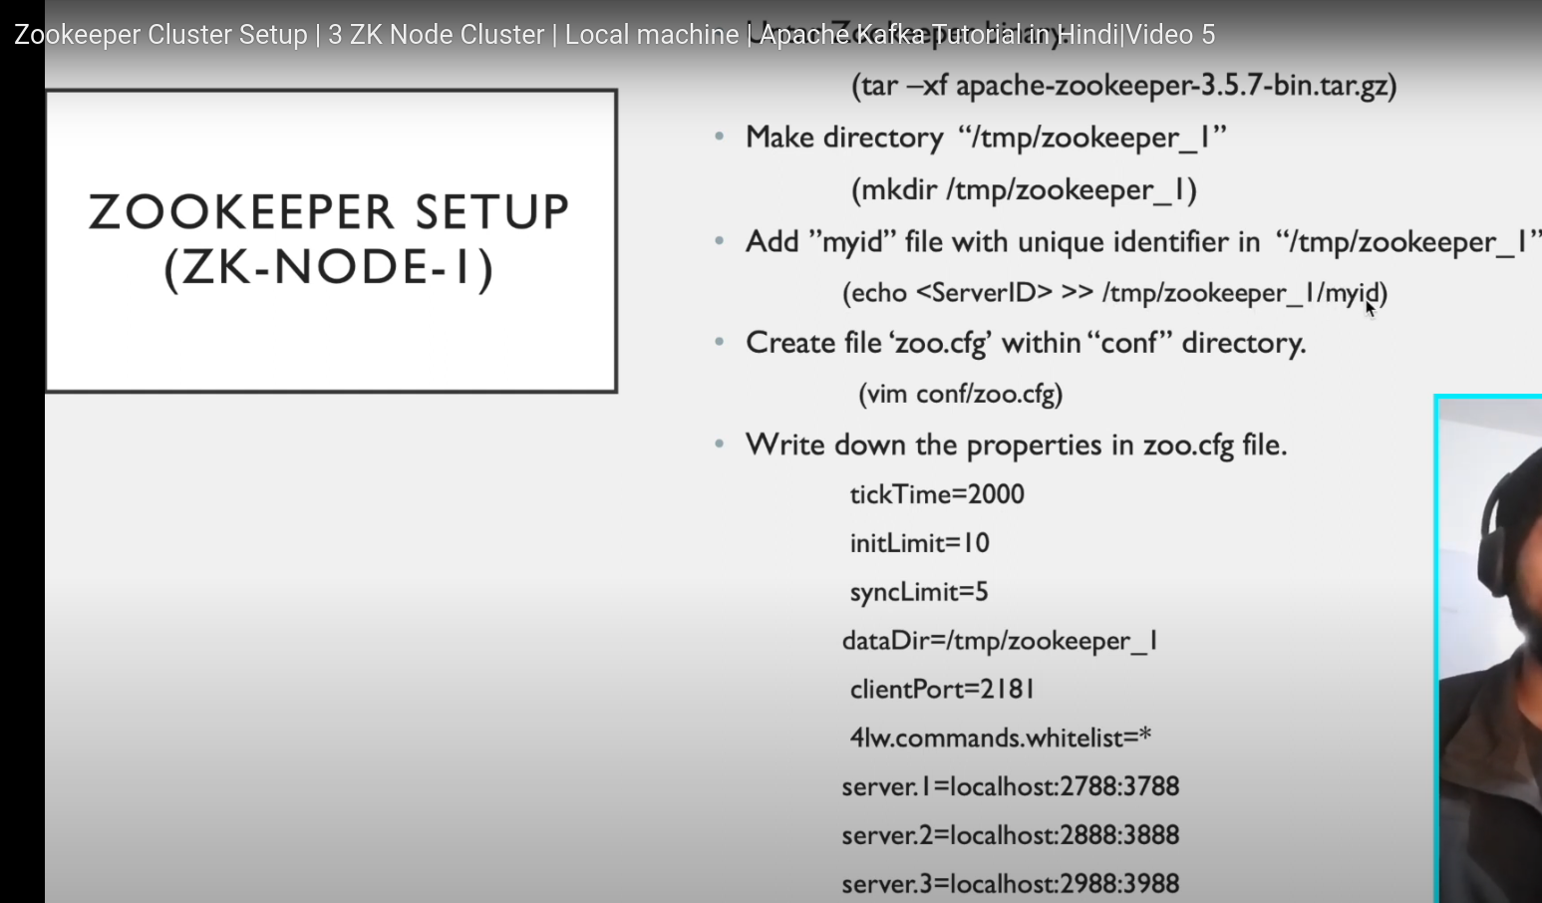

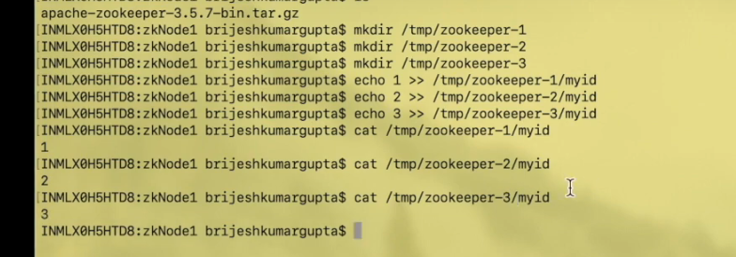

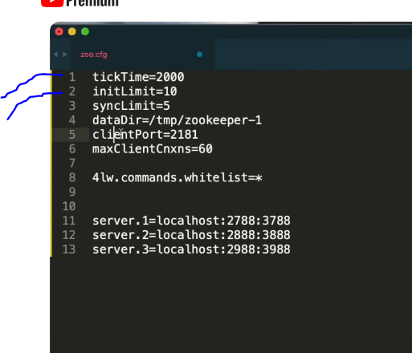

1. time in millisecond
2. Total time given to a node to connect to zookeeper cluster ,here 10 * 2000ms =20 seconds
3. time given to to node to get in sync with zookeeper cluster ,otherwise will be thrown out of cluster
4. Directory where information is kept regarding clients connected to node(zookeeper node)
5. Client can connect with this node on this port
6. Maximum no of clients that can connect to this node
7. –
8. Server.1=localhost:2788:3788 ---> here 11,12,13, line has entries for 3 zookeeper node , 1 ,2,3 is the unique identifier for all three nodes , which needs to be set , localhost i.e. on which ip it is running , next there is 2 ports , first port 2788 is the port, open for peer communication. Zookeeper nodes talks among themselves using this port ,second 3788 is used for leader election among server nodes.

Now ,Create the dataDir and inside that create myId file and create unique identifier as mentioned for all the sever one by one

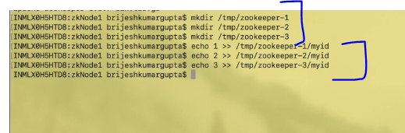

Now run the zookeeper, one by one .

You have now ,3 zookeeper node running in a zookeeper cluster.